**Political Affiliation**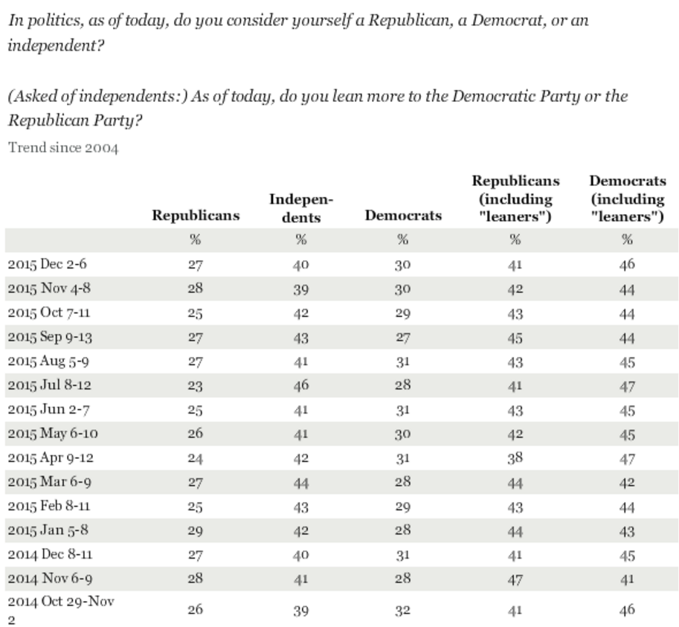

Source: Gallup Poll, *Party Affiliation.* <http://www.gallup.com/poll/15370/party-affiliation.aspx>

**Generational Trends in Political Affiliation**

The Pew Research Center’s [report earlier this month on partisan identification](http://www.people-press.org/2015/04/07/a-deep-dive-into-party-affiliation/) found that 51% of Millennials (18-33 years old in 2014) identify with or lean toward the Democratic Party, while 35% identify as Republicans or lean Republican.  By contrast, 47% of those in the Silent Generation (ages 69-86 in 2014) say they are Republican or lean Republican; 43% affiliate with the Democratic Party or lean Democratic. The partisan leanings of Baby Boomers and Generation X fall in between; both generations favor the Democratic Party, but to a lesser extent than Millennials.

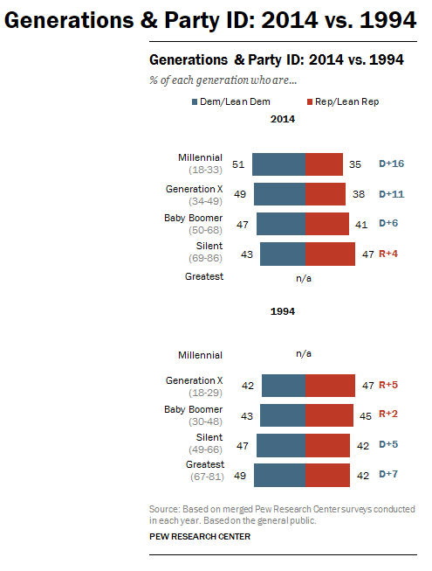 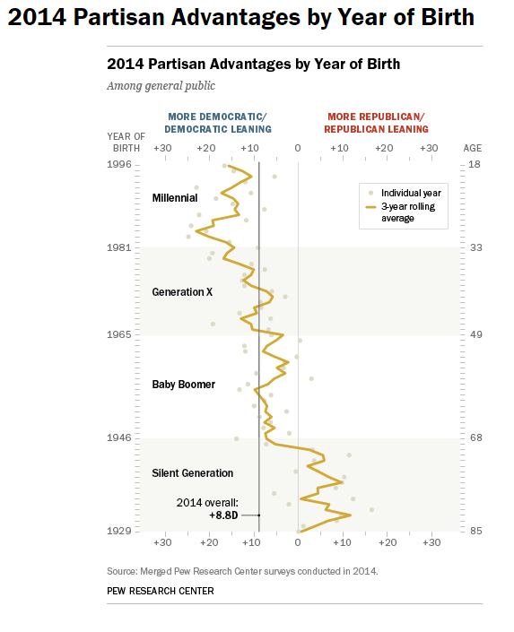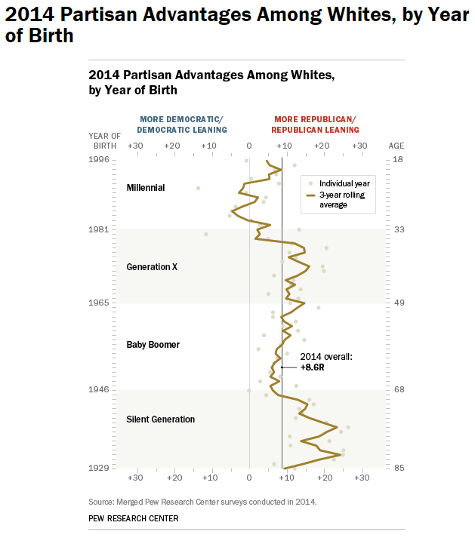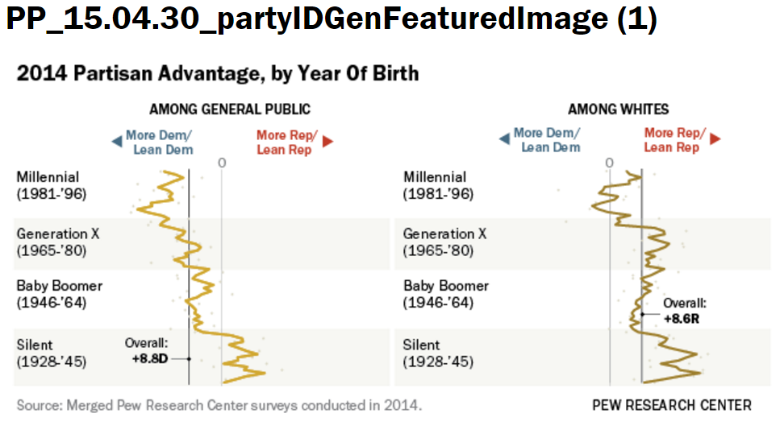

Source: Pew Research Center. *A different Look at Generations and Partisanship.* 4/30/15. <http://www.people-press.org/2015/04/30/a-different-look-at-generations-and-partisanship/>